**Computing Policy**

|  |  |
| --- | --- |
| **Last review date** | May 2025 |

**Intent**

We want pupils to be masters of technology and not slaves to it. Technology is everywhere and will play a pivotal part in students' lives. Therefore, we want to model and educate our pupils on how to use technology positively, responsibly and safely.

We want our pupils to be creators not consumers and our broad curriculum encompassing computer science, information technology and digital literacy reflects this.

We want our pupils to understand that there is always a choice with using technology and as a school we utilise technology to model positive use. We aim to use our computing curriculum to produce lifelong learners using the positive aspects of technology to enhance lives and encourage a healthy lifestyle.

We recognise that technology can allow pupils to share their learning in creative ways. We also understand the accessibility opportunities technology can provide for our pupils. Our knowledge rich curriculum has to be balanced with the opportunity for pupils to apply their knowledge creatively which will in turn help our pupils become skilful computer scientists.

We encourage staff to embed computing across the whole curriculum to make learning creative and accessible. We want our pupils to be fluent with a range of tools to best express their understanding and hope by Upper Key Stage 2, children have the independence and confidence to choose the best tool to fulfil the task and challenge set by teachers.

**The aims of the Computing curriculum at Havannah Primary School are:**

* to provide an exciting, rich, relevant and challenging Computing curriculum for all pupils
* to enthuse and equip children with the capability to use technology throughout their lives.
* to give children access to a variety of high quality hardware, software and unplugged resources
* to instil critical thinking, reflective learning and a ‘can do’ attitude for all our pupils, particularly when engaging with technology and its associated resources.
* to teach pupils to become responsible, respectful and competent users of data, information and communication technology
* to teach pupils to understand the importance of governance and legislation regarding how information is used, stored, created, retrieved, shared and manipulated.
* to equip pupils with skills, strategies and knowledge that will enable them to reap the benefits of the online world, whilst being able to minimise risk to themselves or others.
* to use technology imaginatively and creatively to inspire and engage all pupils, as well as using it to be more efficient in the tasks associated with running an effective school.
* to provide technology solutions for forging better home and school links.
* to utilise computational thinking beyond the Computing curriculum.
* to exceed the minimum government recommended/statutory guidance for programmes of study for Computing and other related legislative guidance (online safety).

**Safeguarding: Online safety**

Online safety has a high profile at Havannah, for all stakeholders. We ensure this profile is maintained and that pupil needs are met by the following:

* A relevant up-to-date online safety curriculum which is progressive from Early Years to the end of Year 6
* We have ‘Online safety’ weeks every year where the ethos is reinforced throughout the school – latest one – week beginning 10/02/2025
* A curriculum that is threaded throughout other curriculums and embedded in the day-to-day lives of our pupils.
* Training for staff and governors which is relevant to their needs and ultimately positively impacts on the pupils. Most recent training – Spring term 2025 – Teach Computing Twilights
* Scheduled pupil voice sessions and learning walks steer changes and inform training needs.
* Through our home/school links and communication channels, parents are kept up to date with relevant online safety matters, policies and agreements. They know who to contact at school if they have concerns.
* Pupils, staff and parents have ‘Acceptable Use Policies’ which are signed and copies freely available.
* Our online safety policy (part of our safeguarding policy) clearly states how monitoring of online safety is undertaken and any incidents/infringements to it are dealt with.
* Filtering and monitoring systems for all our online access.
* Data policies which stipulate how we keep confidential information secure

**Implementation**

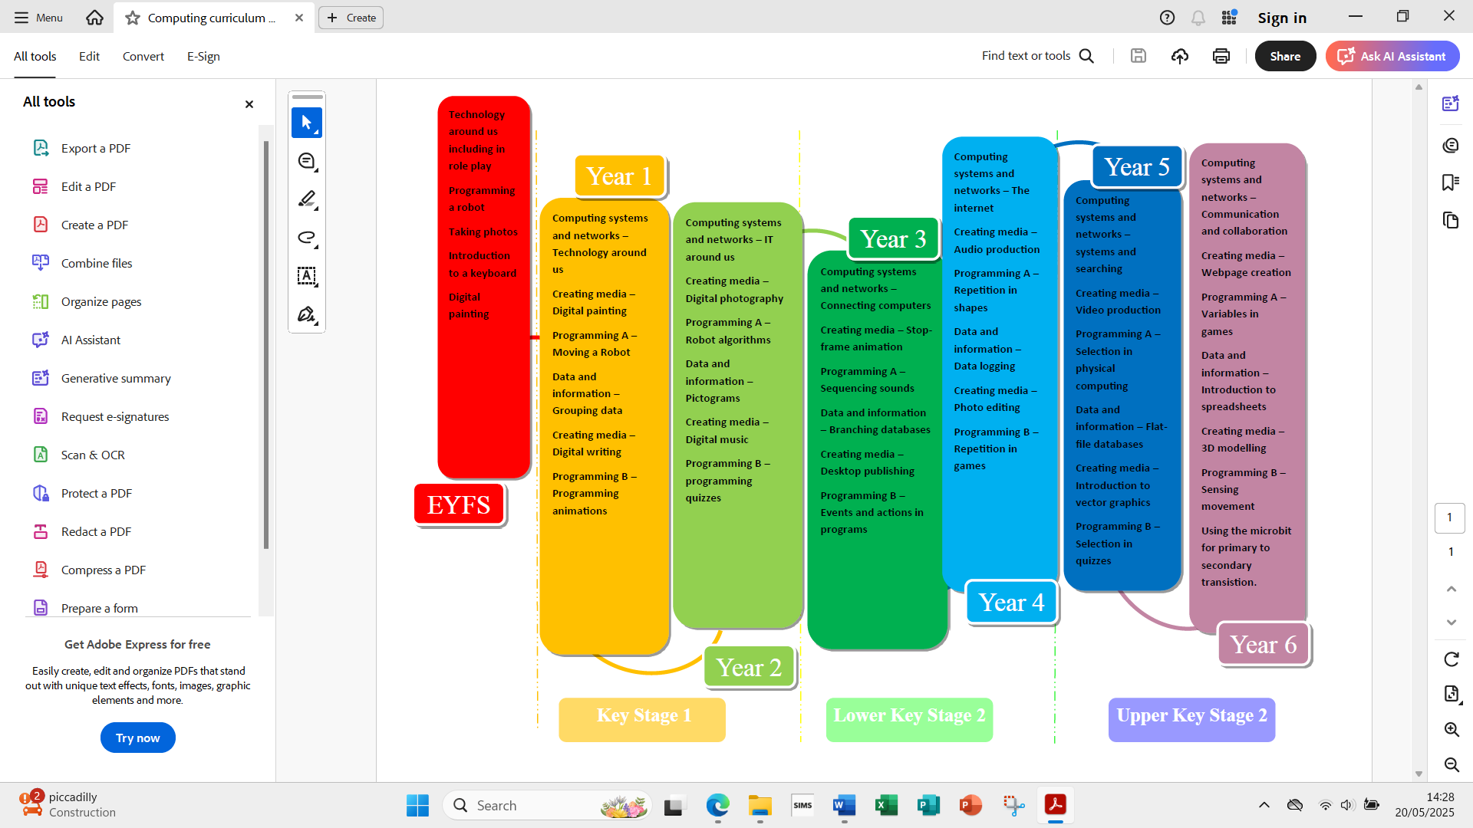

At Havannah Primary School:

Programmes of Study are blocked to allow children to focus on developing their knowledge and skills.

Every year group will build upon the learning from prior year groups therefore developing depth of understanding and progression of skills within the strands of digital literacy, information technology and computer science.

Our children begin their journey with technology in Early Years, with access to iPads and Beebots, as well as some time spent on keyboards exploring where the keys are through role play.

Children have the opportunity to demonstrate their understanding using a variety of hardware (desktop PCs, iPads, laptops and programmable equipment) and software that they need to develop knowledge and skills of digital systems and their applications.

Children have the opportunity to explore and respond to key issues such as digital communications, cyber-bullying, online safety, security, plagiarism and social media.

Online safety and responsible use of technology are topics covered in computing and PSHE lessons, assemblies and during events such as Safer Internet Day.

At the start of each Unit of Work children will review previous learning and will have the opportunity to share what they already know.

Teachers have access to a range of resources and planning from Teach Computing.

Pupils are regularly given the opportunity for self or peer assessment through discussions throughout lessons.

Effective modelling by teachers ensures that children are able to achieve their learning intention, with misconceptions addressed within it.

Differentiation ensures that all pupils can access the computing curriculum.

Children are given clear success criteria in order to achieve the learning intention with differing elements of independence.

Assessment is informed by end of unit assessment, observations during lessons, verbal feedback and pupil voice.

Summative judgements (Working Towards/Working At/Working Above age-related Expectations) are recorded in end of year reports for all KS1 and KS2 pupils (EYFS profile assessment - ELG Understanding the World).

**Computing Curriculum**

As a school, we have chosen the Teach Computing curriculum from Year 1 to Year 6. EYFS follow the EYFS curriculum. The scheme of work supports our teachers in delivering fun and engaging lessons which help to raise standards and allow all pupils to achieve to their full potential. We are confident that the scheme of work more than adequately meets the national vision for Computing. It provides immense flexibility and strong cross-curricular links. Furthermore, it gives excellent supporting material for less confident teachers.

**Early Years**

* Early Years learning environments should feature ICT scenarios based on experience in the real world, such as in role play.
* Pupils gain confidence, control and language skills through opportunities to ‘paint’ on the interactive board/devices or control remotely operated toys.
* Outdoor exploration is an important aspect, supported by ICT toys such as metal detectors, controllable traffic lights and walkie-talkie sets.
* Recording devices can support children to develop their communication skills. This is especially useful for children who have English as an additional language.

**Key Stage 1 outcomes**

* Understand what algorithms are, how they are implemented as programs on digital devices, and that programs execute by following a sequence of instructions.
* Write and test simple programs.
* Organise, store, manipulate and retrieve data in a range of digital formats.
* Communicate safely and respectfully online, keeping personal information private, and recognise common uses of information technology beyond school.

**Key Stage 2 outcomes**

* Design and write programs that accomplish specific goals, including controlling or simulating physical systems;
* Use sequence, selection and repetition in programs; work with variables and various forms of input and output; generate appropriate inputs and predicted outputs to test programs.
* Use logical reasoning to explain how a simple algorithm works and to detect and correct errors in algorithms and programs
* Understand computer networks including the internet; how they can provide multiple services, such as the worldwide web; and the opportunities they offer for communication and collaboration.
* Describe how Internet search engines find and store data; use search engines effectively; be discerning in evaluating digital content; respect individuals and intellectual property; use technology responsibly, securely and safely.
* Select, use and combine a variety of software (including internet services) on a range of digital devices to accomplish given goals, including collecting, analysing, evaluating and presenting data and information.

**Equal Opportunities**

All teaching and non-teaching staff should ensure that all pupils, irrespective of gender, ability, ethnicity and social circumstances, have access to, and make the greatest progress possible, in all areas of the curriculum. Computing provides opportunities for teaching that reinforces this ideal. Special Educational Needs Children with special educational needs are taught the full Computing curriculum which is tailored by their teacher to meet their needs. We place particular emphasis on the flexibility technology brings to allowing pupils to access learning opportunities, particularly pupils with SEN and disabilities. With this in mind, we will ensure additional access to technology is provided throughout the school day and in some cases beyond the school day. Some children may receive additional support to help them take a full and active role in Computing lessons. Tasks will be adapted if necessary to help children to succeed and reach their potential. See Special Education Needs Policy for more details.

**Assessment, Record keeping and Reporting**

* Pupil attainment is assessed against the units of work for Years 1 to 6. Staff will give an working towards, expected or above expected grade for each unit studied.
* Teachers keep accurate records of pupil attainment by entering on a class tick sheet.
* Tracking of attainment is used to inform future planning
* Children are encouraged to self, peer and group assess work in a positive way at the end of each lesson.
* Formative assessment is undertaken each session/interaction in Computing and pupils are very much encouraged to be involved in that process.
* Summative assessment is undertaken in line with the assessment cycle (See Assessment Policy). Using electronic work samples from children’s portfolios on the school server, as well tick sheets and photos of evidence.
* Assessments will be reported to parents at the end of the year on the End of Term report.

**Impact**

**Monitoring and review**

Monitoring standards of teaching and learning within Computing is the primary responsibility of the Computing Lead, (RH). All teachers are expected to keep a portfolio or track children’s work. This portfolio must contain work samples from all areas of the curriculum taught for the year group. Details of monitoring and evaluation schedules can be found in the Computing Action Plan and School Monitoring Schedule.

**Monitoring will be achieved through:**

* Work scrutiny. - Learning walks.
* Observations - Pupil voice.
* Teacher voice - Reflective teacher feedback.
* Learning environment monitoring. - Dedicated Computing Leader and Assessment Leader time.

**Evaluation and Feedback will be achieved through:**

* Dedicated Computing Leader and Assessment Leader time.
* Using recognised standards documentation for end-of-year expectations.
* Using recognised national standards for benchmarking Computing provision in primary schools.
* Written feedback on evaluation of monitoring activities to be provided by the Computing Leader in a timely manner.
* Feedback on whole school areas of development in regard to Computing to be fed back through insets/AOB/staff meetings.

**Roles and Responsibilities**

Due to technology extending beyond the National Curriculum for Computing, there are key roles and responsibilities specific members of staff have.

**Head Teacher**

* Monitoring the implementation of the Computing Policy and its associated policies such as the Safeguarding and SEND Policies.
* Ratifying (in conjunction with the Governing Body) the Computing policy, Safeguarding policy and Computing Leader’s Action Plan.
* Securing technical support service contracts and infrastructure maintenance contracts.
* Approving CPD and training which is in line with the whole school’s strategic plan.
* Approving budget bids and setting them.
* Creating in conjunction with the Computing Leader, a long-term vision for Computing which includes forecasted expenditure and resources.
* Monitoring the performance of the Computing Leader in respect to their specific job role description for Computing.
* Ensuring any government legislation is being met.

**Computing Leader**

* Raising the profile of Computing for all stakeholders.
* Monitoring the standards of Computing and feeding back to staff in a timely fashion so they can act on areas for development.
* Ensuring assessment systems are in place for Computing.
* Maintaining overall consistency in standards of Computing across the school.
* Reporting on Computing at specific times of the year to the Governing Body/Head/Staff.
* Auditing the needs of the staff in terms of training/CPD.
* Actively supporting staff with their day-to-day practice.
* Seeking out opportunities to inspire staff in developing their practice through modelling and sharing new ideas, approaches and initiatives.
* Attending training and keeping abreast with the latest educational technology initiatives.
* Using nationally recognised standards to benchmark Computing.
* Creating Action Plans for Computing and supporting a long-term vision which feeds into the whole school development plan.
* Creating bids for the annual budgets and monitoring budget spend.
* Keeping an up-to-date log of all resources available to staff.
* Procuring physical and online resources that demonstrate best value.
* Reviewing the Computing curriculum and developing it as needed.
* Overseeing the effectiveness of the technician.
* Working as needed with the SENCO/Head Teacher to ensure online safety provision is above adequate and all legislation is in place.

**Technician**

* Conducts routine scheduled maintenance/updates on systems.
* Supports the administration and set-up of online services including the school website.
* Fixes errors/issues with hardware and software set-up, prioritising as needed.
* Routinely checks school filtering, monitoring and virus protection.
* Maintains network connectivity and stability.
* Sets up new hardware and installations.
* Supports the Computing Leader and Head Teacher with future infrastructure needs and associated projected costs.