Daffodil Service!  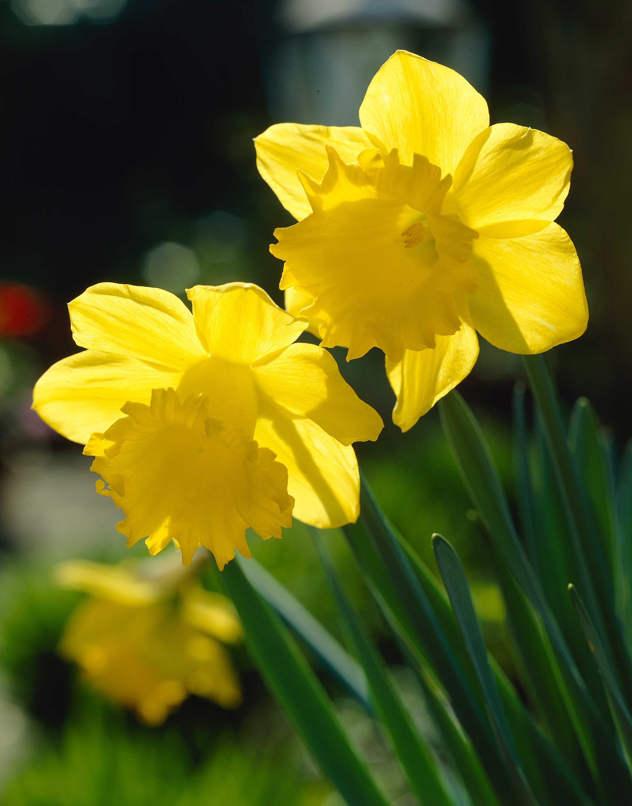  Spring 1  Year 3 | Assessment  Write the initials of the child next to each objective to show the level that they are working at.
Can I… | Working  Towards | Expected | Exceeding
- Sing expressively and creatively to an audience
- Play a recorder using the notes A and B
- Actively listen and comment on songs from around the world
- Understand notation for a crochet, quaver and rest
- Understand what a stave is and write music notes on a stave
- Identify a crochet, quaver and rest within a song
- Create 4 bars of 4 beats on the recorder

End Points – Spring 1 | Assessment  Write the initials of each child to show the level that they are working at.
 | Working Towards | Expected | Exceeding
Can I understand and recognise notation when reading music?
Can I create and perform my own tune and read this from a stave?
Can I show good listening skills and evaluating skills, using music vocabulary to discuss songs from around the world?

The 4 Elements of Success:
- Performing and Playing
- Listening and Evaluating
- Understanding and Exploring
- Create and Compose

Please write the initials of each child next to each objective to show what level they are working at for each objective. This is the same for the end points.

