Knowledge Sheet History

World War 1 Cycle B UKS2

Intent

At Havannah Primary School our intention within History, is to develop within our pupils a deep sense of chronology and an appreciation of the significance of individuals within the shaping of our History.

Our curriculum will nurture a deep sense of inquisitiveness and ingenuity within our pupils and enable children to make connections and transfer skills and knowledge to a variety of learning opportunities. Our uniquely creative curriculum will inspire our pupils, stimulate their curiosity about the past and encourage investigation and critical thought.

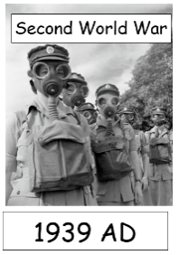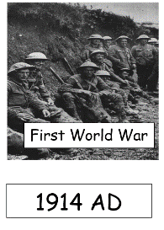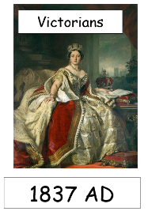

Timeline of chronology

Key Vocabulary

|  |  |
| --- | --- |
| Assassination | the murder of someone famous or important |
| ration | a fixed amount of a commodity officially allowed to each person during a time of shortage |
| trench | a long, narrow ditch |
| Battle of the Somme | a battle of the First World War fought by the armies of the British Empire and French Third Republic against the German Empire |

Key Knowledge

•To compare aspects of life in World War 1 and how those aspects have been impacted by worldwide events.

•To ask and answer questions using a variety of sources to show they know and understand key periods of history and their impact on modern life.

•To understand historical terms. Assassination, women’s land army, rationing, trenches, Battle of the Somme

•To name key historical figures of the period and their significance in terms of change and social development. Archduke Franz Ferdinand, Kaiser Wilhelm II, David Lloyd George.

•To investigate a significant turning point in history. Assassination of Archduke Franz Ferdinand

•To ask and answer historically-valid questions about cause, similarity, difference and significance.

•To use a variety of sources to answer questions and investigate events in history.

•To place key historical figures and events onto a timeline

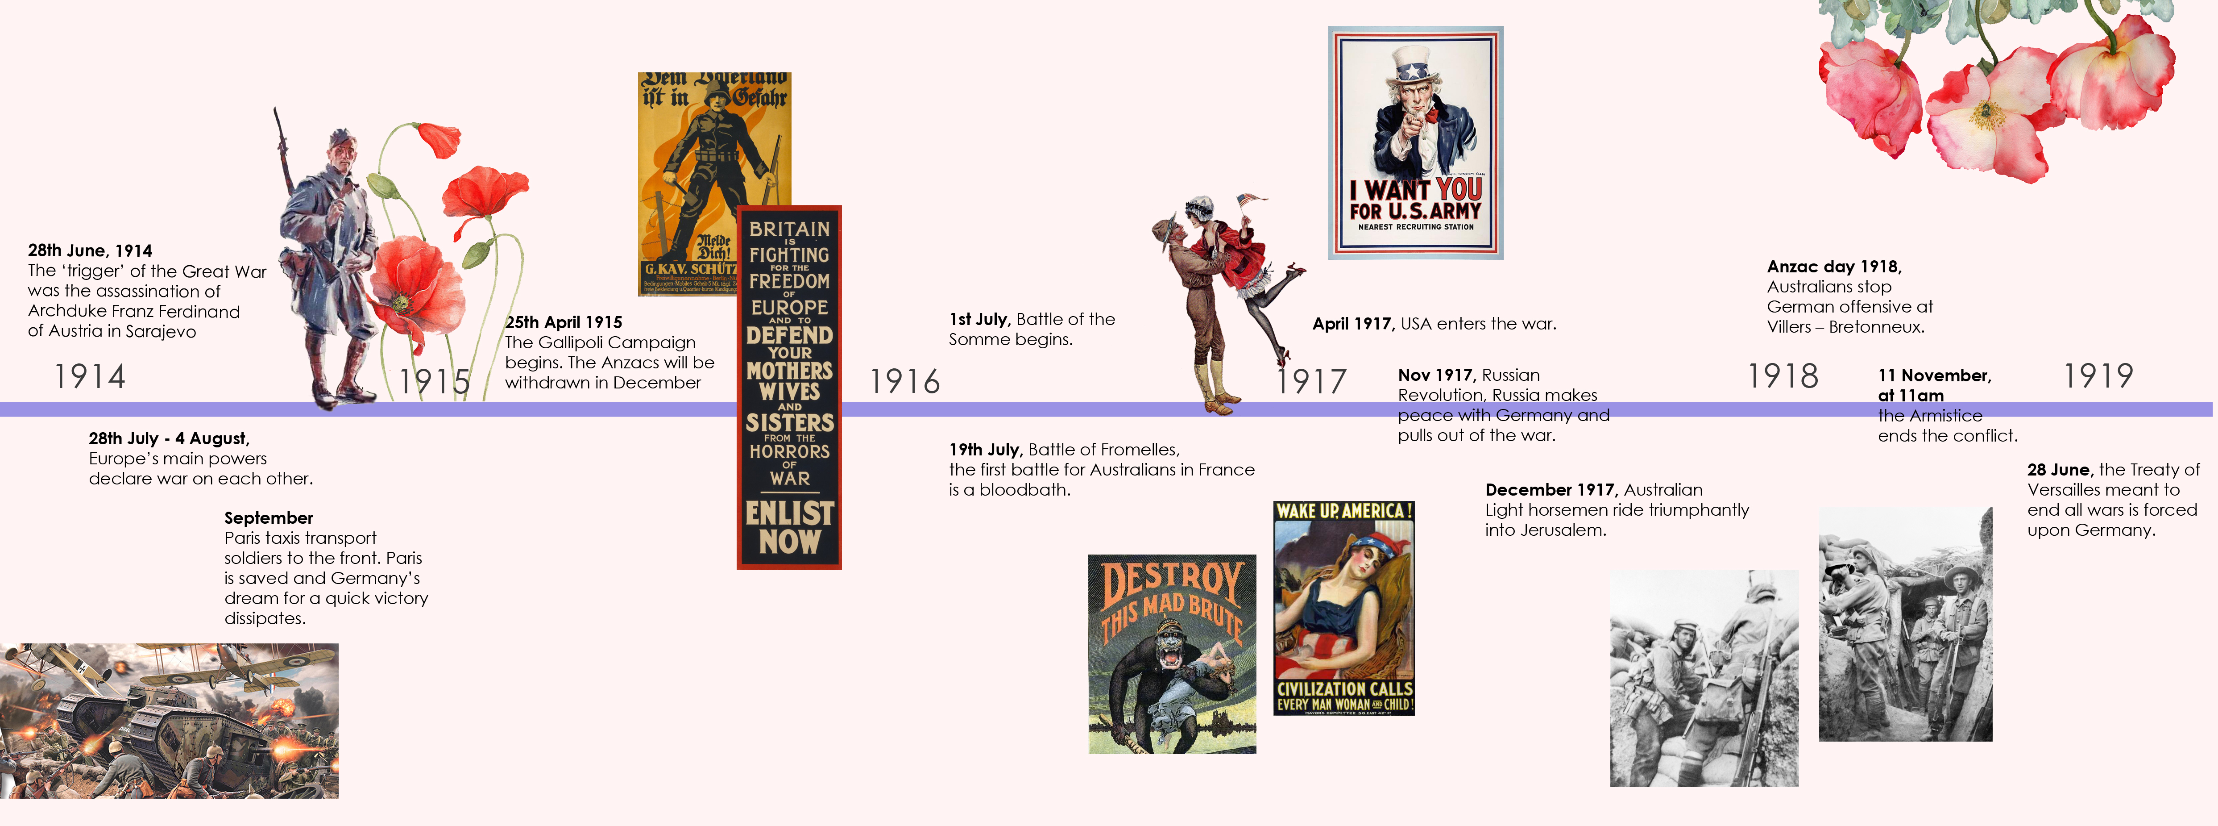

Key Questions

Why did it start?

Who were the different forces?

What happened in the trenches?

How has it impacted modern life?