Knowledge Sheet Geography
Medieval Times Cycle B LKS2
Intent
At Havannah Primary School our intention within Geography, is to develop within our pupils a deep sense of location and place knowledge and supported by map skills and fieldwork.
Our curriculum will nurture a deep sense of inquisitiveness and ingenuity within our pupils and enable children to make connections and transfer skills and knowledge to a variety of learning opportunities. Our uniquely creative curriculum will inspire our pupils, stimulate their curiosity about places and locations and encourage investigation and critical thought.

Key Knowledge

Can I locate European countries including, UK, France, Spain, Italy, Austria, Yugoslavia (as was), Belgium, German?
Can I recall cities of these countries including, Paris, Rome, Lisbon, Marseille, Venice, Brussels and Berlin?
Can I use maps, atlases and globes to identify these countries and cities?
Can I plot these countries and cities on a map?
Can I use digital mapping to identify these countries?

Prior Knowledge
Name and locate the world’s seven continents and five oceans
Name, locate and identify characteristics of the four countries and capital cities of the United Kingdom and its surrounding seas
Use world maps, atlases and globes to identify the United Kingdom and its countries, as well as the countries, continents and oceans studied.

Key Vocabulary

Europe | A continent located in the Northern Hemisphere
Crusades | A series of medieval military expeditions made by Europeans to recover the Holy Land from the Muslims in the 11th, 12th, and 13th centuries
Middle Ages/Medieval Times | The fall of the Roman Empire in the West (5th century) to the fall of Constantinople (1453)
invaded | Entry by armed force to occupy
Roman Empire | the empire established by Augustus in 27 bc and divided by Theodosius in ad 395 into the Western or Latin and Eastern or Greek Empire
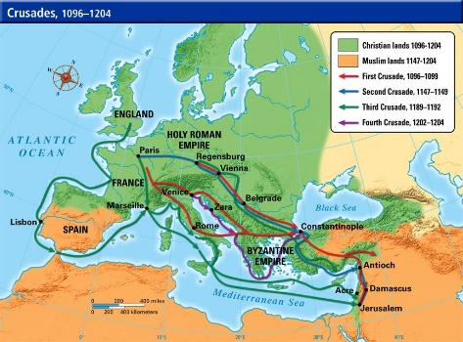
Map of Crusades
Map of Medieval Europe
