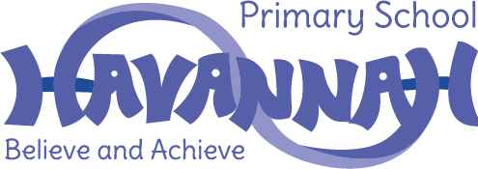

Privacy Notices : Havannah Primary School
Information about pupils in primary and nursery schools
Data Protection Act 1998: How we use pupil information

We collect and hold personal information relating to our pupils and may also receive information about them from their previous school, local authority and/or the Department for Education (DfE). We use this personal data to:

- support our pupils' learning
- monitor and report on their progress
- provide appropriate pastoral care; and
- assess the quality of our services

This information will include their contact details, national curriculum assessment results, attendance information, any exclusion information, where they go after they leave us and personal characteristics such as their ethnic group, any special educational needs they may have as well as relevant medical information.

We will not give information about our pupils to anyone without your consent unless the law and our policies allow us to do so. If you want to receive a copy of the information about your son/daughter that we hold, please contact:

Debra Ball - School Business Manager - 01260 387060 - admin@havannah.cheshire.sch.uk

We are required, by law, to pass certain information about our pupils to our local authority (LA) and the Department for Education (DfE).

DfE may also share pupil level personal data that we supply to them, with third parties. This will only take place where legislation allows it to do so and it is in compliance with the Data Protection Act 1998.

Decisions on whether DfE releases this personal data to third parties are subject to a robust approval process and are based on a detailed assessment of who is requesting the data, the purpose for which it is required, the level and sensitivity of data requested and the arrangements in place to store and handle the data. To be granted access to pupil level data, requesters must comply with strict terms and conditions covering the confidentiality and handling of data, security arrangements and retention and use of the data.

For more information on how this sharing process works, please visit: https://www.gov.uk/guidance/national-pupil-database-apply-for-a-data-extract

For information on which third party organisations (and for which project) pupil level data has been provided to, please visit: https://www.gov.uk/government/publications/national-pupil-database­ requests-received

If you need more in.for.mation about how our local authority and/or DfE collect and us.e your information, please visit:

- our local authority at
http://www.cheshireeast.gov.uk/council and democracy/council information/data protectio n.aspx; or

- the DfE website at https://www.gov.uk/data-protection-how-we-collect-and-share-research­ data

