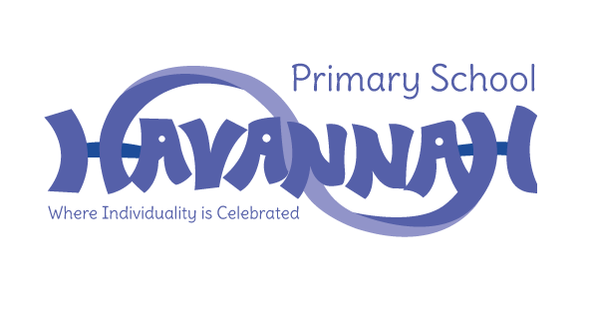
Havannah Primary School
Assessment Results 2022

EYFS – Good Level of Development (GLD)
School | National
66% | 65%

Year 1 – Phonics Screening Check
School | National
90% | 75%

End of Key Stage 1
Subject | School | National
Reading | 76% | 67%
Writing | 48% | 58%
Maths | 66% | 68%

End of Key Stage 2
Subject | School | National
Reading | 85% | 74%
Writing | 70% | 69%
Maths | 81% | 71%
GPS | 85% | 72%
Combined R, W and M | 70% | 59%

