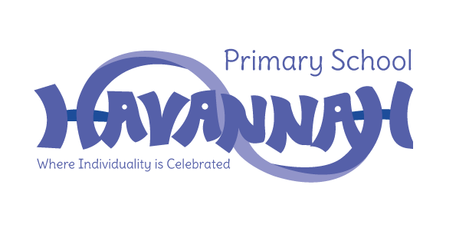
Havannah Primary School
Assessment Results 2019

EYFS – Good Level of Development (GLD)
School | National
77% | 72%

Year 1 – Phonics Screening Check
School | National
87% | 82%

End of Key Stage 1
Subject | School | National
Reading | 83% | 75%
Writing | 77% | 69%
Maths | 73% | 76%

End of Key Stage 2
Subject | School | National
Reading | 76% | 73%
Writing | 76% | 78%
Maths | 83% | 79%
GPS | 76% | 78%
Combined R, W and M | 55% | 65%

