
Havannah Primary School

School Uniform
Policy
Autumn 2019

The wearing of full school uniform is expected as an integral part of the school ethos, which promotes positive attitudes, high standards, and a sense of personal pride. In our view, for a school uniform to be successful it must be:
- Uniform and not open to various interpretations
- Distinctive and smart
- Easily and readily available
- Reasonably priced
Students are expected to wear the correct school uniform as listed below:

For children in Year 1 to Year 6 the uniform will be as follows;

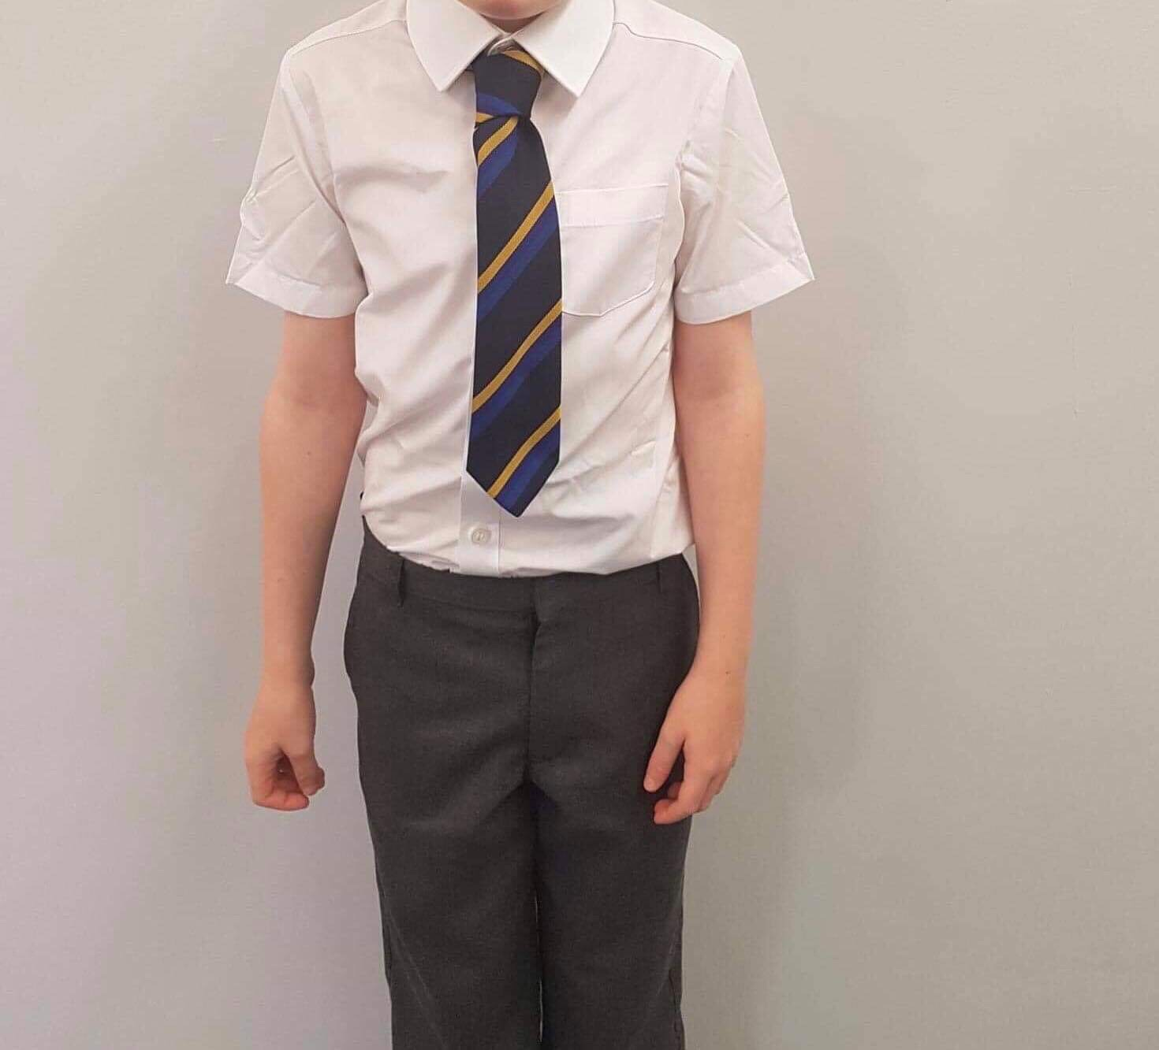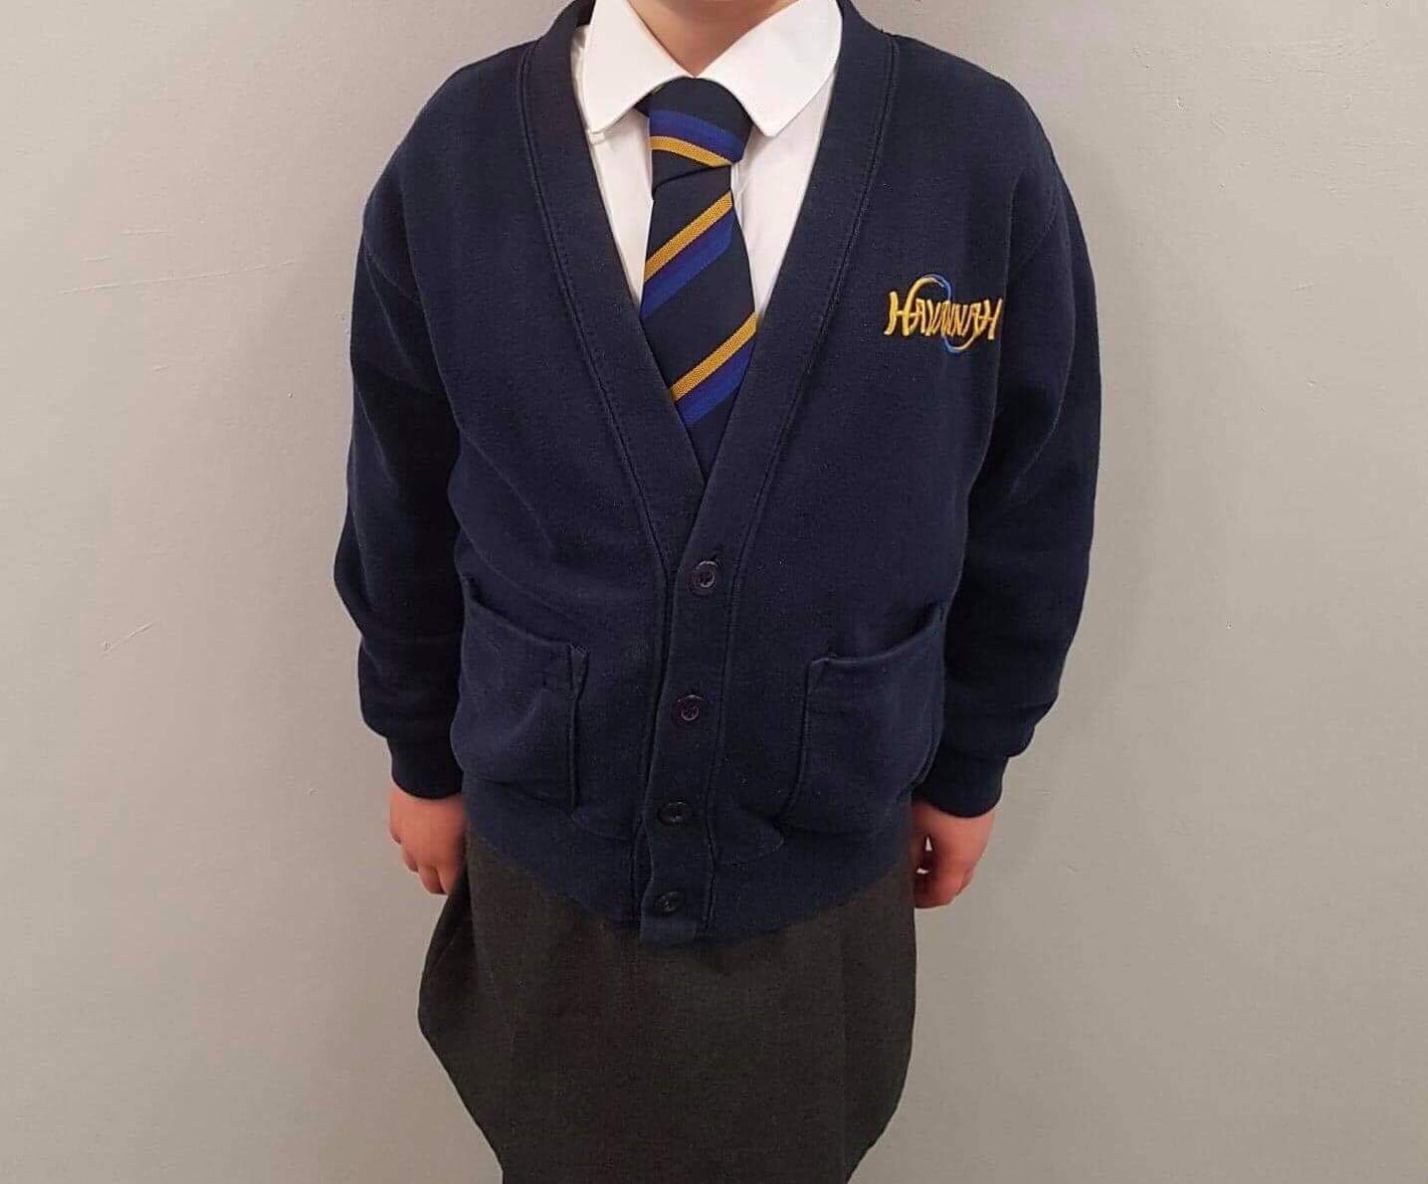
Jumper/Cardigan Long sleeve ‘V’ neck navy jumper /cardigan
Skirt/ Trousers Plain grey trousers, skirt, pinafore or shorts.
Blouse/Shirt White shirt-type blouse/shirt. Long or short sleeved.
Tie New school tie as pictured above, this will be available as a traditional tie or an elastic version.
Dress Navy Blue gingham summer dress may be worn by girls.
Shoes Plain black shoes (not open-toe design, trainers, pump or canvas shoes, mules or sling backs – no coloured laces or stitching).
Socks/Tight Plain white, grey or navy socks or tights.

(All items can be purchased from DP Sportswear)

For children in the Early Years Uniform (Pre-school and Reception Class)
the uniform will be as follows:
White polo shirt with or without Early years school logo.
Purple/Pink/Royal Blue jumpers with Early years colourful logo. (Cardigans will be available shortly in purple and Royal Blue for girls).
Plain grey trousers, skirt, pinafore or shorts.
Navy Blue gingham summer dress may be worn by girls.
Plain black shoes (not open-toe design, trainers, pump or canvas shoes, mules or sling backs – no coloured laces or stitching).
Plain white, grey or navy socks or tights

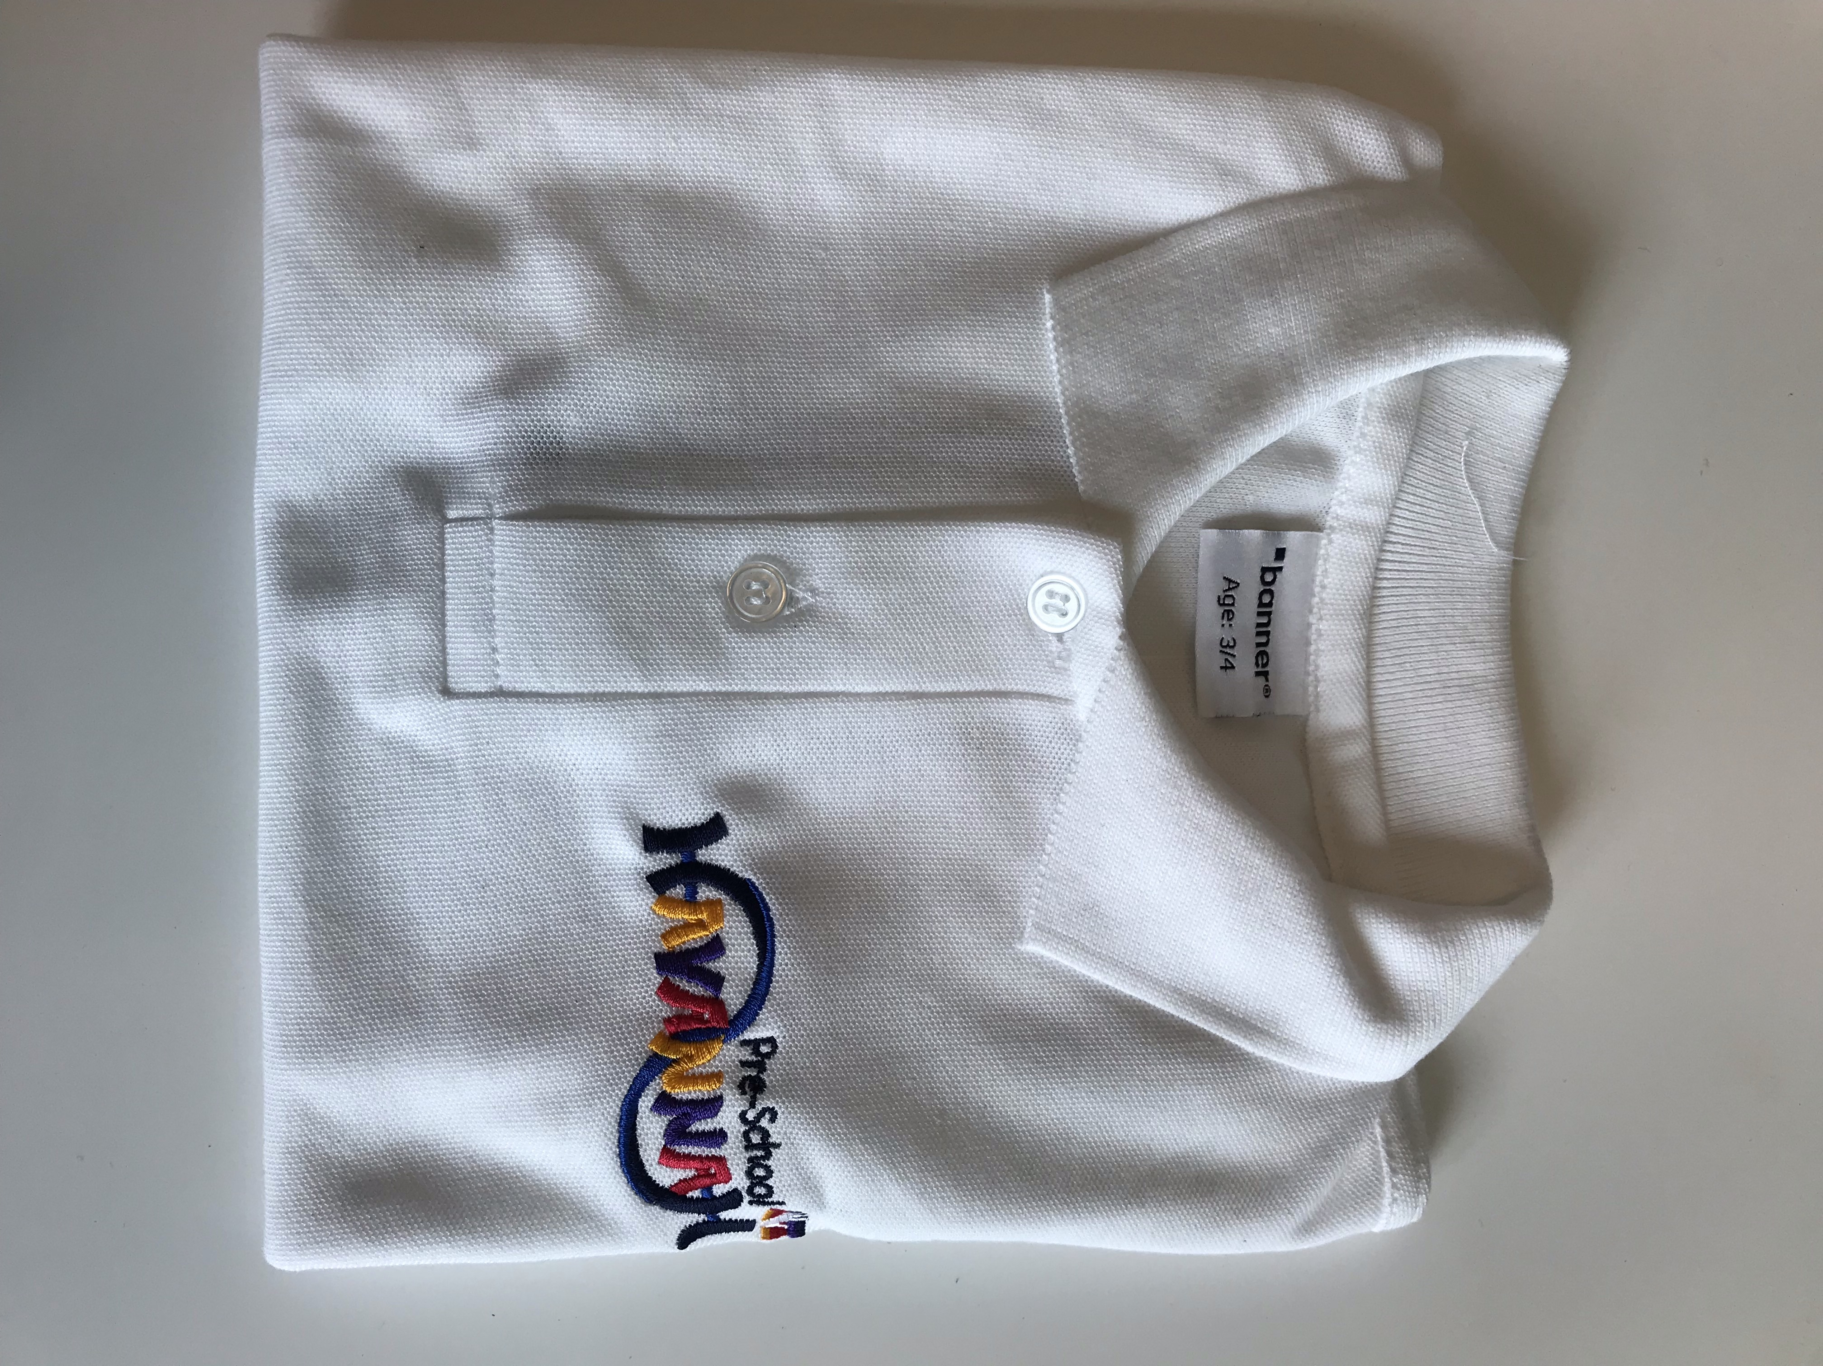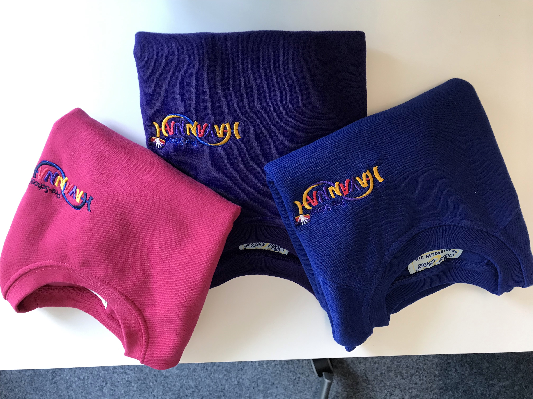
Whole school PE kit will now consist of a white crew neck t-shirt and blue shorts; tracksuits are also available to purchase.
If you have any further queries about the new school uniform, please do not hesitate to contact us.

Where a child is not wearing correct uniform because parents are in financial difficulties, the school will be sensitive to the needs of the pupil; we will discretely provide items of clothing or loan them until new items can be purchased.
All parents are asked to support this policy in a spirit of cooperation for the benefit of all pupils.

