Physical Education Policy
Intent

Physical education and sport at Havannah Primary School have a vital role to play in the physical, social, emotional and intellectual development of children. Physical education and sport are important in giving children the knowledge, understanding and the tools to make informed choices about healthy living and have a positive impact on their own health and well-being. The physical education curriculum at Havannah Primary School, aims to provide for pupils’ increasing self- confidence through an ability to manage themselves successfully in a variety of situations. Children will have the opportunity to take part in a wide range of sports and physical activities, carried out in a safe and supportive environment, where effort and hard-work, as well as success, is celebrated and enjoyment and working together is promoted. Children will also have the opportunity to play competitively in local partnerships and have their achievements recognised and celebrated.

A high-quality physical education curriculum inspires all pupils to succeed and excel in competitive sport and other physically demanding activities. It should provide opportunities for pupils to become physically confident in a way which supports their health and fitness. Opportunities to compete in sport and other activities build character and help to embed values such as fairness and respect.

Our PE aims are:

• To provide a curriculum that meets the requirements of the National Curriculum.
• To provide two hours of high quality physical activity per week for all pupils.
• To provide an environment in which pupils enjoy and are committed to PE and sport.
• To ensure pupils understand that physical activity is an important part of a healthy lifestyle, including social and emotional well-being; both in and out of school and now and in the future.
• To provide all pupils, irrespective of ability, opportunities to experience and succeed in positive, enjoyable and stimulating PE and sport.
• To provide opportunities, within the school (intra) and between schools (inter), for pupils to participate in a range of competitive, creative and challenge-type activities, as individuals and as part of a team.
• To develop competence in the fundamental movement skills and control in gross and fine motor skills.
• To develop stamina, suppleness, strength and agility and the determination and resilience to keep going.
• In lessons, to establish: clear learning objectives and success criteria, opportunities for pupils to demonstrate their knowledge, understanding and competence, challenges to enable pupils to select and use skills with regards to tactics and composition and other opportunities for pupils to communicate, solve problems and make decisions.
• To provide meaningful links to other areas of the curriculum and to national and international agendas.
• To provide an out of school hours’ programme of activities which enables pupils to extend and enrich curriculum provision.
• To establish good habits: an awareness of safety and hygiene and being responsible for PE equipment.

Implementation

Havannah Primary School are lucky enough to be assisted by specialist coaches that work alongside teachers to ensure children have complete coverage of the 2014 National Curriculum for physical education. Bee Active are currently employed to work with teachers and support staff to deliver at least two hours of physical education to Reception through to Year 6. In addition to this, Pre-school enjoy a half hour session weekly. Staff have received a termly CPD session run by Bee Active staff.
The ‘Bumblebees’ programme, created specifically for EYFS, uses themes to get children energised whilst enjoying learning and moving together. It is tailored to the EYFS Statutory Framework, particularly the gross motor skills early learning goal in physical development. Here children negotiate space and obstacles safely, demonstrate strength, balance and coordination and move energetically. Sessions also take into consideration other early learning goals in the three prime areas such as building relationships with turn taking and the managing their self in trying new activities with independence and resilience.
KS1 lessons focus on developing fundamental movement skills, becoming increasingly competent and confident over the two years. Children have access to a broad range of opportunities and equipment to extend their agility, balance and coordination, individually and with others. Lessons have an appropriate focus on engaging competitively and co-operatively in a range of increasingly challenging situations. KS2 lessons build upon this, becoming more sport specific for the children and taking into consideration partnerships competitions annually. Children evaluate their own and others performance, suggesting ways to improve and to strengthen skills. Lessons are knowledge based, as well as skill based, and children learn how to play and compete tactically to achieve own and group success. An overview of coverage can be found later in this policy. Health and wellbeing is hugely important at Havannah and this is taught within practical lessons and in discrete lessons. The profile of PE has improved greatly across the school and teachers have agreed that current practice and provisions are very effective. As a school, Havannah are attending all local partnership competitions and constantly improving in these events, due to the high quality coaching mentioned above and also after school sports clubs run by school staff.

Years 4, 5 and 6 have a half-hour swimming lesson each week for a full term at Congleton Leisure Centre which is taught by specialist swimming teachers from the leisure centre. Swimming teachers from the leisure centre plan and assess the swimming lessons, with classes being split into two or three groups. In the summer term, the Year 4 class are joined by selected children from Years 5 and 6 who are unable to swim the required 25 metres.

Havannah Primary School often receives coaching opportunities from within the local community. We have recently worked with Congleton Rugby Club to deliver tag rugby sessions to Lower Key Stage Two classes.
Havannah Primary School has close links with the secondary schools in Congleton. Sessions are offered which run either in a morning or afternoon for a period of 2 to 3 weeks where a chosen class can attend the school and have lessons in sports we are unable to offer such as trampolining. We have also worked with the secondary schools in dance workshops, tag rugby festivals and many more.

Specialist coaches are employed to lead after school sports clubs giving multiple opportunities for a wide range of sports. These have included archery, dodge ball, gymnastics and football. Children learn new skills and participate in sports which they may not have tried before, whatever their need. There has been the introduction of new, fun and engaging after school clubs such as Glow Sports and Scooter Skills. These have had large numbers of participation. Havannah teaching staff run after school and lunch time clubs to coach teams ready for competitions. These have included netball, football, rounders and athletics. Staff are sometimes assisted by parents that have coaching qualifications in specific sports. A pupil premium incentive scheme is run by Havannah Primary School, where any pupil premium children with 95%+ attendance each half term, can attend a paid club for free, for half a term.

Havannah Primary School has built a high level of participation and achievement in Congleton Education Community Partnership events across a variety of sports and has often progressed to cluster events organised by Sandbach Schools Sports Partnership and then onto county competitions in sports such as basketball and cricket. This year, two football teams progressed to Level 3, competing at the Crewe Soccer Centre. The PE subject leader attends termly CECP meetings to discuss sporting competitions and opportunities in Congleton and the surrounding areas.

On school residentials, children have the opportunity to participate in adventurous sports such as kayaking, rock climbing, paddle boarding and abseiling.

Children in Year 4 and 5 (in this recent year the age group of children has differed due to COVID) are offered a Bikeability course run by the Department for Transport, varying in length per year group. Children gain practical skills and an understanding of how to cycle safely on today’s roads.

Safe Practice
• Pupils are expected to behave in a considerate and responsible manner showing respect for other people and equipment as they would in the classroom.
• Pupils come to school dressed ready in their PE kit on their specified day.
• Parents are informed of PE days at the beginning of the year and if they will ever need any specific kit such as warm, outdoor clothing.
• Pupils are expected to wear their Physical Education kit- shorts, T-shirt and bare feet or pumps unless health reasons specify otherwise. Pupils should wear pumps or trainers for outside games activities.
• Teachers wear appropriate clothing and footwear. All teachers follow the same procedure with their
children, with regard to jewellery and long hair.
• Jewellery is not allowed in school except one stud earring in each ear. These should be removed or covered with tape for PE.
• Pupils will be made aware of, and encouraged to discuss, safety implications relating to themselves and others during PE lessons.
• If an accident occurs during a P.E lesson, all pupils to stop the learning to so that full attention can be
given to the injured child.
• The child is either sent to receive First Aid, or if it is a serious injury, a responsible child should be sent to retrieve a fully trainer first aider.
• Any child with an inhaler will take it outside for PE
• When attending competitions and events the school should also provide a First Aider with a fully stocked first aid kit.
• Swimming is organised and led by qualified staff at Congleton Leisure Centre where appropriate
emergency systems are in place.
• The wearing of goggles for swimming is not encouraged but each case is looked at individually if there
is a medical problem and parental consent is required.
• Girls should wear one-piece swimming costumes and hats if desired and boys should wear swimming trunks and not shorts.

Travel for sporting events
Havannah staff may drive children to and from sporting events with permission from parents or carers. Staff are required to provide photocopies of valid insurance and MOTs to the school office to be covered by the school insurance when transporting children. Children must never be alone with a member of staff in a vehicle. There should be another member of staff or another child present. Recently, we have been asking parents to transport their own children to and from events with only a small number of children requiring transport.

PE Curriculum
The national curriculum defines the content of the school curriculum for PE:
Key Stage 1
Pupils should develop fundamental movement skills, become increasingly competent and confident and access a broad range of opportunities to extend their agility, balance and coordination, individually and with others. They should be able to engage in competitive (both against self and against others) and co-operative physical activities, in a range of increasingly challenging situations.
Pupils should be taught to:
• master basic movements including running, jumping, throwing and catching, as well as developing balance, agility and co-ordination, and begin to apply these in a range of activities
• participate in team games, developing simple tactics for attacking and defending
• perform dances using simple movement patterns
Key Stage 2
Pupils should continue to apply and develop a broader range of skills, learning how to use them in different ways and to link them to make actions and sequences of movement. They should enjoy communicating, collaborating and competing with each other. They should develop an understanding of how to improve in different physical activities and sports and learn how to evaluate and recognise their own success.
Pupils should be taught to:
• use running, jumping, throwing and catching in isolation and in combination
• play competitive games, modified where appropriate [for example, badminton, basketball, cricket, football, hockey, netball, rounders and tennis], and apply basic principles suitable for attacking and defending
• develop flexibility, strength, technique, control and balance [for example, through athletics and gymnastics]
• perform dances using a range of movement patterns
• take part in outdoor and adventurous activity challenges both individually and within a team
• compare their performances with previous ones and demonstrate improvement to achieve their personal best

Swimming and water safety
All schools must provide swimming instruction either in key stage 1 or key stage 2.
In particular, pupils should be taught to:
• swim competently, confidently and proficiently over a distance of at least 25 metres
• use a range of strokes effectively [for example, front crawl, backstroke and breaststroke]
• perform safe self-rescue in different water-based situations

Early Years
Children should develop the fundamental skills of moving and handing involving agility, balance, coordination, throwing, catching, jumping and kicking. Children show good control and co-ordination in large and small movements. They move confidently in a range of ways, safely negotiating space. They handle equipment and tools effectively.
Teachers and specialist coaches work in collaboration to follow the long term PE plan below. This ensures coverage of the curriculum and that progress in skills and knowledge is made.
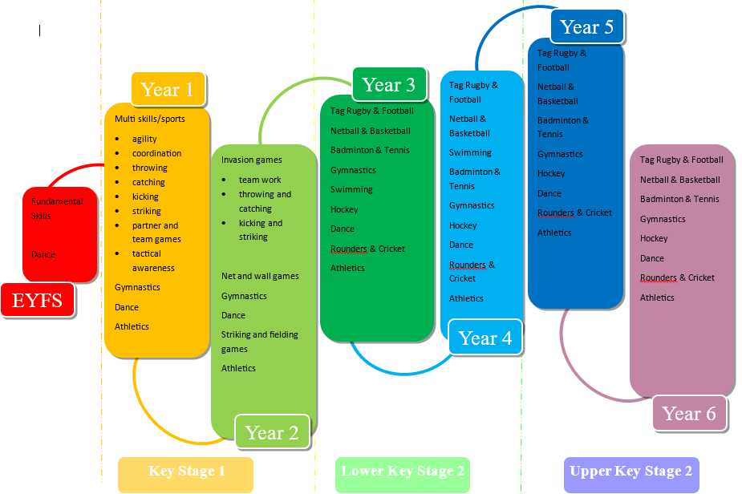

Equal Opportunities
All teaching and non-teaching staff should ensure that all pupils, irrespective of gender, ability, ethnicity and social circumstances, have access to, and make the greatest progress possible, in all areas of the curriculum. PE provides opportunities for teaching that reinforces this ideal. Special Educational Needs Children with special educational needs are taught the full PE curriculum which is tailored by their teacher to meet their needs. Some children may receive additional support to help them take a full and active role in PE lessons. Tasks will be adapted if necessary to help children to succeed and reach their potential. See Special Education Needs Policy for more details.

Assessment, Record keeping and Reporting
Formative assessment is carried out by Bee Active staff during or at the end of every lesson. They also carry out summative assessment but this is done collaboratively with class teachers. Assessment is recorded on the Honeycomb system which is run by Bee Active but is also frequently used and accessed by class teachers with their own log-ins. The Honeycomb systems uses formative and summative assessment to work out a percentage for each child which then leads to a working towards, working at expected or working above standard for each child. It is also very useful in showing which children have exceeded in specific sports and which children require more support. It is interesting to see how this differs with children across the different sports. This information is crucial and beneficial for teachers in report writing and parents evening. The system also keeps track of what has been taught in lessons to ensure coverage of the curriculum and progress in skills and knowledge.

Impact

As a result of the curriculum, pupils are inspired to succeed and excel in competitive sport and other physically demanding activities. It provides opportunities for pupils to become physically confident in a way which supports their health and fitness. Opportunities to compete in sport and other activities build character and help to embed values such as fairness and respect. Children are aware of the importance of a healthy and active lifestyle and have specific sporting skills that have progressed through the years.

Monitoring and review
The role of the PE subject leader is to:
- To liaise with specialist coaches regarding planning, assessment, recording and competitions.
- To keep up to date with local and national developments in PE and disseminate relevant information.
- To lead staff meetings/ CPD.
- To develop and review action plans and share with staff and link governors.
- To report PE and Sport Premium funding on school website and evaluate its impact.
- To organise teams and staff to attend competitions along with obtaining permission from parents.
- To monitor planning and teaching of PE.
- To ensure assessment system is up to date.
- To attend CECP sports cluster meetings

The subject leader monitors and collects planning from both teachers and specialist coaches to ensure coverage of the National Curriculum. Examples of lesson plans can be found in the PE folder and the full range is available for viewing electronically on Honeycomb. There are regular lesson observations of all staff involved in delivering Physical Education lessons and these are assessed against the teaching standards.

Staff training is led by specialist coaching staff alongside the physical education lead. These may be in areas such as progression of skills across the year groups or how to plan a successful PE lesson. This term we have focused on sport specific coaching as this is what staff felt they needed. Teaching members of staff also observe PE lessons taught by specialist coaches every week for a select half term, filling in lesson observations and monitoring the progress of select children.

It is also the role of the subject leader to audit and monitor use of equipment. All PE equipment is kept in a designated shed on the playground and is kept locked at all times. Staff are responsible for retrieving and returning equipment and children should not be allowed to do so without adult supervision. Playground equipment is kept in a smaller shed on the playground which children have free access to at break and lunch times. The school has a great range of sports kits that children wear when representing the school at sporting events and fixtures. These are safely kept by the subject lead and are handed back into the school office where a member of staff ticks them back in on a register. This method has really helped to keep track of sport kits and collect them all back in as there is sometimes a quick turn around needed.

