Maths Policy
Spring 2024

Members of staff responsible: Miss R Kitson
Governor Committee: Teaching and Learning
Date approved: Spring 2024
Date to be reviewed: Spring 2026
Maths Policy

Overarching Vision
Our aim at Havannah Primary School is for all children to enjoy mathematics and have a secure and deep understanding of fundamental mathematical concepts and procedures when they leave us to go to secondary school. We want children to see the mathematics that surrounds them every day and enjoy developing vital life skills in this subject.

Aims for our pupils
• To develop a growth mindset and positive attitude towards mathematics.
• To become confident and proficient with number, including fluency with mental calculation and look for connections between numbers.
• To become problem solvers, who can reason, think logically, work systematically and apply their knowledge of mathematics.
• To develop their use of mathematical language.
• To become independent learners and to work co-operatively with others.
• To appreciate real life contexts to learning in mathematics.

Introduction
In September 2022, Havannah Primary School began transitioning towards a mastery approach to the teaching and learning of mathematics. Mastering maths means pupils of all ages acquiring a deep, long-term, secure and adaptable understanding of the subject. The phrase ‘teaching for mastery’ describes the elements of classroom practice and school organisation that combine to give pupils the best chances of mastering maths. Achieving mastery means acquiring a solid enough understanding of the maths that’s been taught to enable pupils to move on to more advanced material. We understood that this would be a gradual process and take several years to embed. The rationale behind changing our approach to teaching mathematics lay within the NCETM Maths Hub Programme as well as the 2014 National Curriculum, which states:
• The expectation is that most pupils will move through the programmes of study at broadly the same pace.
• Pupils who grasp concepts rapidly should be challenged through being offered rich and sophisticated problems as well as their understanding being challenged through careful questioning, before any acceleration through new content.
• Those who are not sufficiently fluent with earlier material should consolidate their understanding, including through additional practice, before moving on.

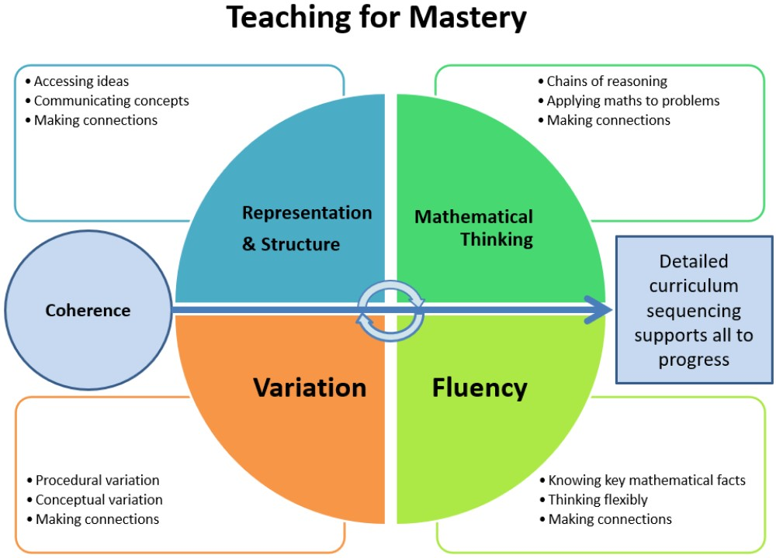
The 5 Big Ideas

Our teaching for mastery is underpinned by the NCETM’s 5 Big Ideas.
• Opportunities for Mathematical Thinking allow children to make chains of reasoning connected with the other areas of their mathematics.
• A focus on Representation and Structure ensures concepts are explored using concrete, pictorial and abstract representations, the children actively look for patterns and generalise whilst problem solving.
• Coherence is achieved through the planning of small, connected steps to link every question and lesson within a topic.
• Teachers use both procedural and conceptual Variation within their lessons and there remains an emphasis on Fluency with a relentless focus on number and times table facts.

Primary Teaching for Mastery
In September 2022, Havannah Primary School began and later successfully completed our Primary Teaching for Mastery Development year ran by The Maths Hub in coordination with the NCETM (National Centre for Excellence in the Teaching of Mathematics). This was the first year of the continuing programme to develop teaching for mastery in maths in primary schools. More details of the development year can be found below.
Primary Teaching for Mastery – Development | NCETM
In September 2023, Havannah Primary School commenced the Primary Teaching for Mastery Embedding year, a collaborative professional development for schools in their second year of teaching for mastery. Further details can be found below.
Primary Teaching for Mastery - Embedding | NCETM
In this project, Work Groups support schools to scale up teaching for mastery approaches from individual teachers’ classrooms, ensuring whole-school practices are consistently adopted. There are at least five workshops across the year, plus support and school visits from a Mastery Specialist. From participation in the project so far, Havannah Primary School has enhanced mathematical subject knowledge, emphasising key areas of maths. Staff participating have and will plan, teach and reflect on lessons with a mastery approach. School leaders will understand the school-wide structures which enable staff to develop mastery approaches and will establish systems to support ongoing professional learning within school.

Implementation
As part of our work with The Maths Hub, Havannah Primary School decided to take a coherent and consistent approach to the delivery of maths throughout Havannah Primary School. Therefore, in September 2023, we successfully implemented Power Maths.

Power Maths
Created especially for UK primary schools, and aligned with the new National Curriculum, Power Maths is a whole-class, textbook-based mastery resource that empowers every child to understand and succeed. Power Maths rejects the notion that some people simply ‘can’t’ do maths. Instead, it develops growth mindsets and encourages hard work, practice and a willingness to see mistakes as learning tools. Best practice consistently shows that mastery of small, cumulative steps builds a solid foundation of deep mathematical understanding. Power Maths combines interactive teaching tools, high-quality textbooks and continuing professional development (CPD) to help you equip children with a deep and long lasting understanding. Based on extensive evidence, and developed in partnership with practising teachers, Power Maths ensures that it meets the needs of children in the UK. Power Maths and Mastery Power Maths makes mastery practical and achievable by providing the structures, pathways, content, tools and support you need to make it happen in your classroom. To develop mastery in maths children need to be enabled to acquire a deep understanding of maths concepts, structures and procedures, step by step. Complex mathematical concepts are built on simpler conceptual components and when children understand every step in the learning sequence, maths becomes transparent and makes logical sense. Interactive lessons establish deep understanding in small steps, as well as effortless fluency in key facts such as tables and number bonds. The whole class works on the same content and no child is left behind.
In key stage 1 children develop the core ideas that underpin all calculation. They begin by connecting calculation with counting on and counting back, but they should learn that understanding wholes and parts will enable them to calculate efficiently and accurately, and with greater flexibility. They learn how to use an understanding of 10s and 1s to develop their calculation strategies, especially in addition and subtraction. In lower key stage 2 children develop the basis of written methods by building their skills alongside a deep understanding of place value. They should use known addition/subtraction and multiplication/division facts to calculate efficiently and accurately, rather than relying on counting. Children use place value equipment to support their understanding, but not as a substitute for thinking. In upper Key Stage 2, children build on secure foundations in calculation, and develop fluency, accuracy and flexibility in their approach to the four operations. They work with whole numbers and adapt their skills to work with decimals, and they continue to develop their ability to select appropriate, accurate and efficient operations.
Lesson Sequence
At the heart of Power Maths is a unique lesson sequence designed to empower children to understand core concepts and grow in confidence. Embracing the National Centre for Excellence in the Teaching of Mathematics’ (NCETM’s) definition of mastery, the sequence guides and shapes every Power Maths lesson you teach.
Power Up
Each lesson begins with a Power Up activity which supports fluency in key number facts. Power Ups reinforce key skills such as times-tables, number bonds and working with place value.
Discover
A practical, real-life problem arouses curiosity. Children find the maths through story-telling. A real-life scenario is provided for the Discover section.
Share
Teacher-led, this interactive section follows the Discover activity and highlights the variety of methods that can be used to solve a single problem.
Think Together
Children work in groups on the carpet or at tables, using their textbooks or eBooks.
Practice
Using their Practice Books, children work independently on questions that follow small steps of progression to deepen learning. The questions begin with pictorial support and then progress with a range of varied fluency with decreasing support and finally a challenge section.
Reflect
The Reflect section (like a plenary) is your opportunity to check how deeply children understand the target concept.

Power Maths in Reception
Power Maths Reception fully covers the 2021 Early Learning Goals. Children develop the core ideas that underpin all calculation. They begin by connecting calculation with counting on and counting back, but they should learn that understanding wholes and parts will enable them to calculate efficiently and accurately, and with greater flexibility. Children record their calculations in their own ways, there is no expectation of number sentences at this stage, however children may choose this way to record their thinking. The consistent use of the CPA (concrete, pictorial, abstract) approach across Power Maths helps children develop mastery across all the operations in an efficient and reliable way. In Reception, children focus on concrete and pictorial representations. At this stage, children focus on representing objects in different ways e.g. understanding that 5 cars can also be represented as 5 counters, 5 cubes, 5 pictures of cars, etc. The lesson sequence of Power Maths in Reception is slightly different to KS1 and KS2. Instead of Discover, Share, Think Together, Practice and Reflect being part of a daily lesson, they are instead the focus for a particular day of the week. For example, Monday in Reception is Discover, Tuesday is Share and so on. Reception children have journals rather than practice books to journal their understanding. These journals also offer ideas for continuous provisions as well as ideas for support lower and higher achievers to further extend learning.
Power Maths Individual Practice Games
The Power Maths programme also provides teachers with a range of online games per unit which consolidates understanding. These can be used in school as part of lessons but are also allocated, as homework, to children via the Pupil World on Active Learn (the Power Maths platform). Here, children can log in from home and complete the set game.

Mathematics guidance: key stages 1 and 2
In addition to Power Maths which fully covers the 2014 National Curriculum, teachers also use the Mathematics guidance for key stages 1 and 2. This publication provides non-statutory guidance from the Department for Education. It has been produced to help teachers and schools make effective use of the National Curriculum to develop primary school pupils’ mastery of mathematics. This publication aims to bring greater coherence to the national curriculum by exposing core concepts in the national curriculum and demonstrating progression from year 1 to year 6. It also summarises the most important knowledge and understanding within each year group and important connections between these mathematical topics. Teachers use this guidance to identify key small steps (from Power Maths) which must be mastered before moving on. The NCETM provide resources for each of the ready to progress criteria, which are used by teachers at Havannah for pre-teaching or consolidation of core concepts. Power Maths provides a curriculum map for each year group which matches the relevant Power Maths lessons to the ready to progress criteria.

Mastering Number
In Reception, Year 1 and Year 2 we are taking part in the ‘Mastering Number’ programme. This is run by NCETM (National Centre for Excellence in the Teaching of Mathematics) and the Maths Hub who fully fund the programme. This project aims to secure firm foundations in the development of good number sense for all children from Reception through to Year 1 and Year 2. The aim over time is that children will leave KS1 with fluency in calculation and a confidence and flexibility with number. Attention will be given to key knowledge and understanding needed in Reception classes, and progression through KS1 to support success in the future. A daily teaching session for all children of 10 to 15 minutes is needed, in addition to their normal maths lesson. We are looking forward to working the NCETM and the Maths Hub on planned, exciting projects in the very near future.

Times Tables Rock Stars
In either paper form or online, Times Tables Rock Stars is a carefully sequenced programme of daily times tables practice. It can be used in school or children can access their account online at home. Each week concentrates on a different times table, with a recommended consolidation week for rehearsing the tables that have recently been practised every third week or so. This format has very successfully boosted times tables recall speed and is very useful for the new Year 4 Times Tables Test. At Havannah Primary School, the maths lead will set weekly or fortnightly tournaments/battles on Times Tables Rock Stars. These may be between different year groups, boy and girls or even children and teachers. Children are rewarded with Dojos for taking part and certificates for being one of the top players in their tournament. This is celebrated and shared with parents via the school Dojo page. This really boosts participation within school and encourages further discussion around maths.

Mathematics in Pre-School
How children learn about numbers and develop mathematical understanding during the pre-school years is vitally important and sets them on a path towards numeracy skills and confidence in later life. Mathematics sits within the specific areas of the Early Years Curriculum and features heavily within our curriculum and provision. Through creative units of work, the children investigate challenges set within the context of stories as well as working on a set of core number skills.
Throughout the year children work on:
Number recognition
Subitising
Cardinality and counting
Pattern
Shape
Space and measure

Staff work with children either through; direct teaching, small group work or play partnering to develop children’s learning from their own starting point and ensure that children are provided with opportunities to investigate, explore and question. Through partnerships with our parents we are able to successfully encourage the profile of Mathematics both at home and at school, and support children to ensure that they have the best start to their Mathematical journey.

Resources
Each classroom is stocked with daily mathematical equipment: manipulatives and visuals to support pupils’ learning. Teachers should plan for these to be regularly used during lessons. Children should also be encouraged to independently select resources that will help them with their understanding of mathematical concepts. A range of mathematical equipment for measuring and geometry work is located centrally in the mathematics cupboard in the Year 3 and 4 corridor. Smaller resources such as protractors, dice and arrow cards are in green boxes outside the Year 5 and 6 classrooms. Our resources have recently been audited, for the implementation of Power Maths, which has led to an increase in the number of resources available.
Every classroom needs to have a learning wall for maths which should support the current learning and display key mathematical language for children.

ICT
All teachers are encouraged to use ICT to enhance teaching and learning in mathematics where appropriate. Every classroom is equipped with a C-Touch screen and all pupils have access to laptops and iPads. Opportunities will be provided for the children to apply and develop their ICT capabilities in mathematics through:
• mathematical software installed on iPads
• floor turtles in EYFS
• databases, spreadsheets and graph plotting programmes
• frequent use of Active Learn on laptops
• Purple Mash offers lots of exciting games for maths practice
• Times Tables Rock Stars

Presentation in books
Children should be encouraged to take pride in the appearance of their work in maths. Children have their individual Power Maths Practice Books which they will record in once they have completed the matching Power Maths lesson. In addition to this, children also have a squared maths jotter. Children record their understanding of maths in these during the teacher led input, where as whiteboards were used previously. These jotter books are also used for any journaling, pre-teaching or consolidation work needed alongside Power Maths.

Equal Opportunities
All teaching and non-teaching staff should ensure that all pupils, irrespective of gender, ability, ethnicity and social circumstances, have access to, and make the greatest progress possible, in all areas of the curriculum. Maths provides opportunities for teaching that reinforces this ideal. Special Educational Needs Children with special educational needs are taught the full maths curriculum which is tailored by their teacher to meet their needs. Some children may receive additional support to help them take a full and active role in maths lessons. Tasks will be adapted if necessary to help children to succeed and reach their potential. See Special Education Needs Policy for more details.

Assessment, Record keeping and Reporting
The assessment and recording of achievement and coverage will be ongoing throughout the year. Formal assessments will be carried out every half term using the Power Maths Progress Tests. The results are then uploaded online onto the Power Maths mark book. Summative termly assessment data will be recorded onto pupils tracking data sheets on DCPro by each class teacher and progress will be closely monitored. This data, alongside Teacher Assessments will be reported to the Headteacher, Assessment coordinator, link governor and Maths Subject Leader. Children in Foundation Stage are assessed using the Early Learning Goals. Teacher Assessment judgments are monitored and may be moderated by the SLT and Subject Leader. Daily teacher assessments will inform the short term planning whilst the formal assessments will be used for medium term planning, target setting and grouping of children within teaching groups. Analysis of results to inform teaching and learning and feedback to children on their next steps is crucial.

Marking
Evidence of mathematics should be recorded daily in either Power Maths Practice Books or maths jotters. In the Practice Books, if children have required a substantial amount of support in a lesson, then their work should also be coded T (teacher support) or TA (teaching assistant support). If work is not coded, then it can be assumed that children have completed their work mostly independently. Next to the date and title in Practice Books, teachers should give one (satisfactory), two (good) or three (excellent) ticks in pink pen. Teachers should identify any misconceptions or corrections in green pen. All of the above should be carried out daily as essential marking. At their discretion, teachers can give a next step in learning, whether to correct answers to secure understanding or moving onto the next level with a challenge. The teacher also writes this in green pen. Children should complete these in purple pen. VF (verbal feedback) is used to show a teacher has discussed a child’s work with them. If children are self-assessing or peer assessing then this should be carried out in purple pen along with a peer assessment label if a friend has assessed it. For further information see the Marking Policy.

Monitoring and review
The maths subject leader is to:
• ensure that teachers are familiar with the Power Maths materials and advise/support them to plan appropriate lessons
- ensure teachers are equipped with resources for pre-teaching or consolidation that may be needed alongside Power Maths.
• analyse and monitor data about pupil progress
• monitor teaching and learning through lesson observations, learning walks, monitoring of planning and book scrutiny
• lead by example in the way they teach in their own classroom
• teach demonstration lessons to model good practice
• prepare, organise and lead INSET/staff meetings with the support of the Headteacher
• work co-operatively with the SENCO
• observe colleagues with a view to identifying the support that they may need
• attend regular Subject Leadership training and report back to staff
• keeps parents informed about Mathematics at Havannah with mathematic evenings
• discuss regularly with the Headteacher and the link governor for maths the attainment and progress of maths throughout the school
• positively promote the subject
• create an annual action plan, in-line with the school development plan
• work alongside Maths link governor for additional quality assurance and monitoring.
- continue to attend the Primary Teaching for Mastery teacher research groups, half termly.

- attend Mastery events provided by The Maths Hub.

Monitoring of the subject will take part termly and will involve:
- Planning and book looks
- Interviews with pupils
- Conversations with staff
- Learning walks
- Lesson observations
- Coaching opportunities with staff
- Checking assessments are up to date
- Monitoring impact and children’s progress in interventions
- Identifying and tracking specific groups of children, for example recovery children in 2020.

Entitlement
Key Stage 1 54 hours per year approximately 1 ½ hours per week
Key Stage 2 72 hours per year approximately 2 hours per week.

