Knowledge Sheet Geography
World War 1 Cycle B UKS2
Intent
At Havannah Primary School our intention within Geography, is to develop within our pupils a deep sense of location and place knowledge and supported by map skills and fieldwork.
Our curriculum will nurture a deep sense of inquisitiveness and ingenuity within our pupils and enable children to make connections and transfer skills and knowledge to a variety of learning opportunities. Our uniquely creative curriculum will inspire our pupils, stimulate their curiosity about places and locations and encourage investigation and critical thought.

Key Vocabulary
Europe | A continent located in the Northern Hemisphere
Capital City | A city or town where the government is based for that country
Location | A particular place or position
Triple Entrente | An informal understanding between Russia, UK and France
Central Powers | An understanding between Germany, Austria, Hungary, Turkey

Key Knowledge
Can I locate European countries including, UK, France, Italy, Germany, Austria, Hungary, Turkey, Russia
Can I recall the capital cities of these countries including, Paris, Rome, Berlin, Vienna, Budapest, Ankara, Moscow
Can I use maps, atlases and globes to identify these countries?
Can I use digital mapping to identify these countries?

Prior Knowledge
I know where Europe is on a map.
I can identify Italy, Scandinavia and UK within Europe.
I can use a map, atlas and globe.

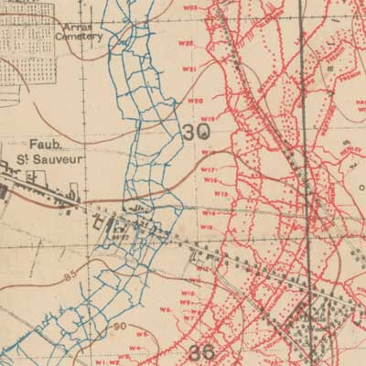
Map of the
trenches
Map of the Europe during WWI
