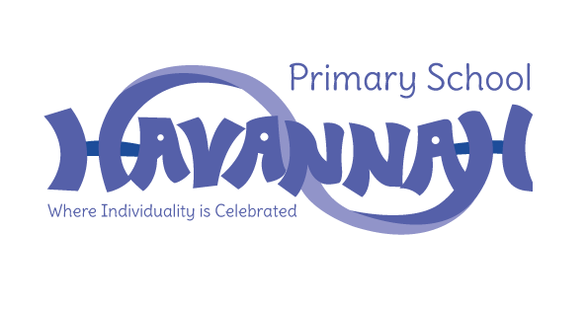
Havannah Primary School
Assessment Results 2023

EYFS – Good Level of Development (GLD)
School | National
82% | 67%

Year 1 – Phonics Screening Check
School | National
86% | 79%

End of Key Stage 1
Subject | School | National
Reading | 62% | 68%
Writing | 55% | 60%
Maths | 79% | 70%

End of Key Stage 2
Subject | School | National
Reading | 85%  (52% Greater Depth) | 73%
Writing | 67%  (3% Greater Depth) | 71%
Maths | 85%  (52% Greater Depth) | 73%
GPS | 79%  (55% Greater Depth) | 72%
Combined R, W and M | 67% | 60%

