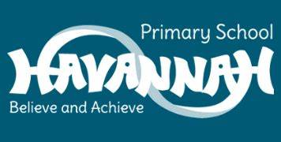
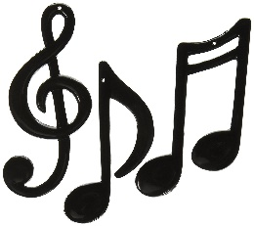
Year 6 Music End Points

- Can I perform creatively and expressively in unison to an audience?
- Can I use a range of notation to create short phrases that included a range of The 8 Elements of Music?
- Can I evaluate music and share my ideas and thoughts to a group?
- Can I improvise over a range of music using my musical instincts?
- Can I confidently perform an instrument as a solo to my class?
- Can I show how to write notation on a stave and follow this when playing my instrument?
- Can I understand how to follow a conductor and show an understanding of their instruction?
- Can I show how to follow and produce notation on a stave that show the correct pitch?
- Can I improvise using my instrument?
- Can I write my own music and produce this on a stave?
- Can I evaluate my own performance and give myself a goal to achieve?

