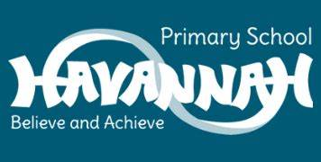
Year 1 Music End Points

- Can I perform to an audience?
- Can I listen to and discuss a piece of music using vocabulary taught?
- Can I show an understanding of composing and creating a sound?
- Can I perform expressively to an audience?
- Can I recognise notation on a stave and identify them?
- Can I show an understanding that different notation create a different sound?
- Can I perform / play expressively to an audience?
- Can I confidentially play a tuned instrument in unison?
- Can I show an understanding when the tempo, pitch, rest and beat changes in a song?
- Can I perform / play expressively to an audience?
- Can I understand that different genres of music such as rock and musical theatre will have a different effect on the feelings of the audience?
- Can I show expression and feeling through song and using my opinions?

